

Requirement & Design Specification
Auction Online System
Version: 1.4

– Da Nang, June 2026 –

Record of Changes

Version | Date | A*  M, D | In charge | Change Description
V1.0 | 28/8 | A | Tuan | Update Usecase
v1.1 | 15/6 | A | Tuan | Add screen flow
V1.2 | 22/6 | A | Tuan | Update Database and add non-ui function
V1.3 | 29/6 | M | Tuan | Complete requirement specifications, design specifications, database descriptions, package descriptions, and appendix for Auction Online System.
V1.4 | 30/6 | M | Long | Update Use_Case
*A - Added M - Modified D - Deleted

Contents
Record of Changes 2
I. Overview 6
1. User Requirements 6
1.1 Actors 6
1.2 Use Cases 6
a. Diagram(s) 6
b. Descriptions 11
2. Overall Functionalities 13
2.1 Screens Flow 13
2.2 Screen Descriptions 13
2.3 Screen Authorization 14
2.4 Non-UI Functions 15
3. System High Level Design 16
3.1 Database Design 16
a. Database Schema 16
b. Table Descriptions 17
3.2 Code Packages 18
II. Requirement Specifications 19
1. Register 19
1.1 UC-01_Register 19
a. Functionalities 19
b. Business Rules 19
2. Common Functions 20
2.1 UC-2_Login System 20
a. Functional Description 20
b. Business Rules 20
2.2 UC-03 - Login with Google 21
2.3 UC-04 - Reset Password 21
3 . Member 22
3.1 UC-05 - Update Profile 22
3.2 UC-06 - Submit KYC Verification 22
4 . Member Wallet 23
4.1 UC-07 - Access Wallet Dashboard 23
4.2 UC-08 - Deposit Funds 23
4.3 UC-09 - Request Withdrawal 23
5. Auction Discovery 24
5.1 UC-10 - Browse Auctions 24
5.2 UC-11 - Search & Filter Auctions 24
6 . Buyer 25
6.1 UC-12 - Register for Auction 25
6.2 UC-13 - Pay Deposit 25
6.3 UC-14 - Join Auction Room 26
6.4 UC-15 - Verify Room Access 26
6.5 UC-16 - Place Bid 26
6.6 UC-17 - Settle Order Payment 27
7 . Seller 27
7.1 UC-18 - Request Auction Creation 27
7.2 UC-19 - Sign Product Commitment 28
7.3 UC-20 - Evaluate Product via AI 28
7.4 UC-21 - Monitor Auction 29
7.5 UC-22 - View Settlement / Payout 29
8 . Scheduler / Payment 29
8.1 UC-23 - Close Auction Automatically 29
8.2 UC-24 - Refund Deposit 30
9 . Staff 30
9.1 UC-25 - Verify and Approve Products 30
9.2 UC-26 - Approve KYC Profiles 31
9.3 UC-27 - Approve Withdrawal Requests 31
9.4 UC-28 - Handle Support Requests 32
10 . Admin 32
10.1 UC-29 - Manage User Accounts 32
10.2 UC-30 - Set Roles & Permissions 32
10.3 UC-31 - Configure Bidding Rules 33
10.4 UC-32 - Configure Financial Policies 33
10.5 UC-33 - Edit Categories & Attributes 34
10.6 UC-34 - Manage Notifications 34
10. 7 UC-35 - View Auction History (System-wide) 35
10.8 UC-36 - View Revenue Statistics 35
10.9 UC-37 - Export Data Reports 35
10.10 UC-38 - View System Audit Logs 36
10.11 UC-39 - Resolve Disputes 36
III. Design Specifications 37
1. <<Feature Name>> 37
1.1 <<SubFeature Name>> 37
a. <<Screen/Function Name>> 37
1.2 System Access 37
a. User Login 37
b. Setting List 39
c. Setting Details 40
IV. Appendix 41
1. Assumptions & Dependencies 41
2. Limitations & Exclusions 42
3. Business Rules 42
4. .. 43

I. Overview

1. User Requirements

1.1 Actors

# | Actor | Description
1 | Guest | An unauthenticated user who can browse public auctions, view general information, and register for a new account.
2 | Member | An authenticated user who has logged into the system. They can manage their personal profile, use the e-wallet, and submit KYC verification.
3 | Buyer | A verified member who participates in auction rooms, places bids on products, and completes payments for won auctions.
4 | Seller | A verified member who requests the creation of new auction sessions, signs product commitments, and monitors the bidding process of their items.
5 | Staff | A system operator responsible for daily moderation tasks, such as verifying products, approving KYC profiles, and handling user support tickets.
6 | Admin | A high-level administrator who manages global system configurations, oversees staff accounts, resolves disputes, and analyzes revenue statistics.
7 | Scheduler | An automated internal background process responsible for executing time-based tasks, such as automatically closing auctions when the time expires.
8 | Payment Gateway | An external third-party service (e.g., VNPay, Stripe) that securely processes financial transactions, including deposits, order settlements, and refunds.

1.2 Use Cases

a. Diagram(s)

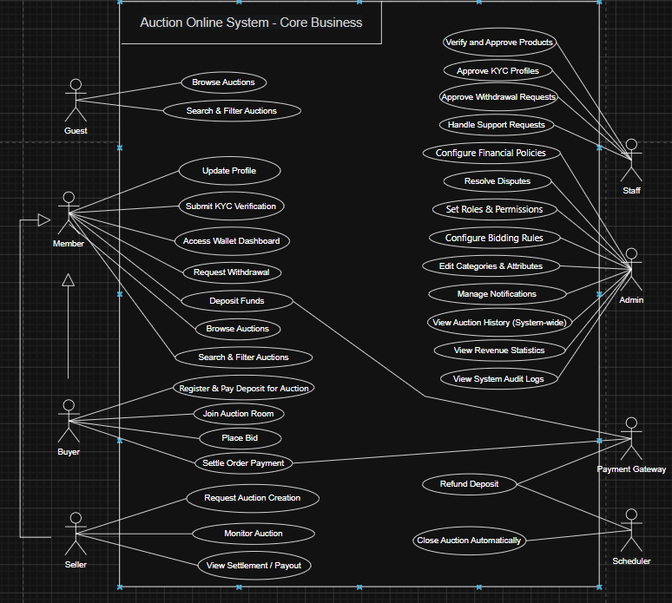

Picture 1. Auction online system usecase diagram
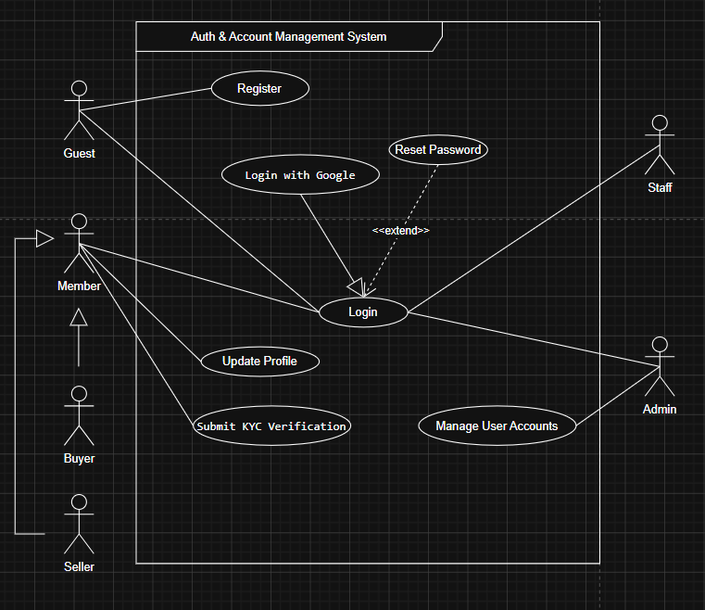

Picture 2. Authentication and account management use case diagram

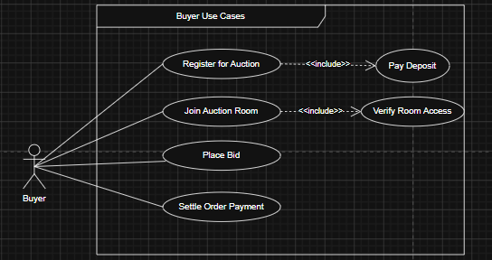

Picture 3. Buyer use case diagram

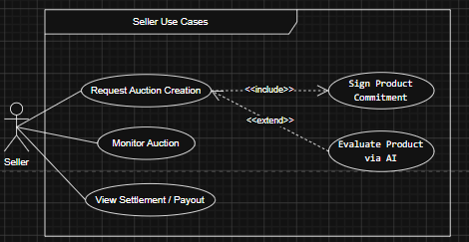

Picture 4. Seller use case diagram
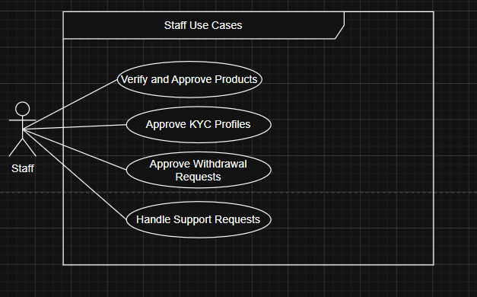

Picture 5. Staff use case diagram

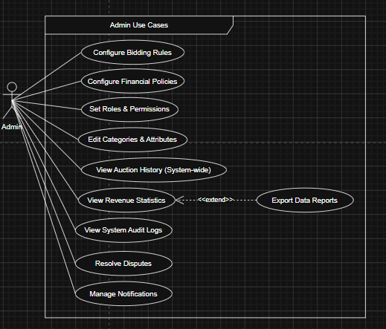

Picture 6. Admin use case diagram

b. Descriptions

ID | Feature | Use Case | Use Case Description
01 | Auth & Account | Register | Allows a Guest to create a new account to become a Member of the system.
02 | Auth & Account | Login | Allows a Guest or Member to authenticate and access their account.
03 | Auth & Account | Reset Password | Allows a user to recover access to their account by verifying their email and setting a new password.
04 | Auth & Account | Update Profile | Allows a Member to update their personal information, such as avatar, address, and contact details.
05 | Auth & Account | Submit KYC Verification | Allows a Member to upload identity documents to verify their identity before participating in auctions.
06 | Core Bidding | Browse Auctions | Allows a Buyer to view a list of ongoing, upcoming, or completed auction sessions.
07 | Core Bidding | Search & Filter Auctions | Allows a Buyer to find specific products using keywords, categories, or price filters.
08 | Core Bidding | Register for Auction | Allows a Buyer to register their intent to participate in a specific upcoming auction session.
09 | Core Bidding | Verify Room Access | An internal check to ensure the Buyer meets all requirements (e.g., paid deposit, KYC approved) before entering a live room.
10 | Core Bidding | Join Auction Room | Allows a qualified Buyer to enter a live auction room to observe or place bids.
11 | Core Bidding | Place Bid | Allows a Buyer to submit a new price for a product during a live auction session.
12 | Core Bidding | Request Auction Creation | Allows a Seller to create a new auction listing by providing product details, images, and starting price.
13 | Core Bidding | Sign Product Commitment | A mandatory step for a Seller to digitally agree to terms regarding product authenticity and condition.
14 | Core Bidding | Evaluate Product via AI | Provides an AI-generated price suggestion and evaluation based on the product description and images.
15 | Core Bidding | Monitor Auction | Allows a Seller to track the live bidding status, current highest bid, and participants of their active auctions.
16 | Core Bidding | Close Auction Automatically | The system Scheduler automatically ends the auction at the specified time, locks bidding, and determines the final winner.
17 | Payment & Wallet | Access Wallet Dashboard | Allows a Member to view their current e-wallet balance and transaction history.
18 | Payment & Wallet | Deposit Funds | Allows a Member to add money to their e-wallet via an external Payment Gateway.
19 | Payment & Wallet | Request Withdrawal | Allows a Member to request a cash-out of their wallet funds to their personal bank account.
20 | Payment & Wallet | Pay Deposit | Allows a Buyer to pay the required upfront deposit from their wallet to secure a spot in an auction room.
21 | Payment & Wallet | Settle Order Payment | Allows the winning Buyer to pay the final remaining balance for the won product.
22 | Payment & Wallet | Refund Deposit | System automatically returns the initial deposit to Buyers who participated but did not win the auction.
23 | Staff | Verify and Approve Products | Allows Staff to review and approve/reject new auction requests created by Sellers.
24 | Staff | Approve KYC Profiles | Allows Staff to manually review users' submitted identity documents and update their verification status.
25 | Staff | Approve Withdrawal Requests | Allows Staff to review and approve users' requests to withdraw funds to ensure no fraudulent activity.
26 | Staff | Handle Support Requests | Allows Staff to respond to user inquiries, tickets, and general platform issues.
27 | Admin | Resolve Disputes | Allows Admin to handle escalated conflicts (e.g., payment issues, fake products) and make final judgments.
28 | Admin | Set Roles & Permissions | Allows Admin to assign specific roles and system access levels to different Staff members.
29 | Admin | Configure Bidding Rules | Allows Admin to adjust settings that affect the live auction experience, such as anti-sniping time, minimum bid increments, and maximum auction duration.
30 | Admin | Edit Categories & Attributes | Allows Admin to define and edit product categories and their specific descriptive attributes.
31 | Admin | Manage Notifications | Allows Admin to broadcast system-wide alerts, emails, or push notifications to specific user groups.
32 | Admin | View System-wide History | Allows Admin to monitor all past and present auction sessions for auditing and transparency purposes.
33 | Admin | View Revenue Statistics | Allows Admin to view visual dashboards, graphs, and data regarding platform earnings and commissions.
34 | Admin | Export Data Reports | Allows Admin to download revenue or activity data into structured files (e.g., CSV, PDF) for external reporting.
35 | Admin | View System Audit Logs | Allows Admin to view detailed logs of all system events and Staff actions for security tracking.
36 | Auth & Account | Manage User Accounts | Allows Admin to view user details, suspend, ban, or unban user accounts based on platform policy violations.
37 | Admin | Configure Financial Policies | Allows Admin to set monetary rules for the platform, including commission rates, required deposit percentages, and payment deadlines.

2. Overall Functionalities

2.1 Screens Flow

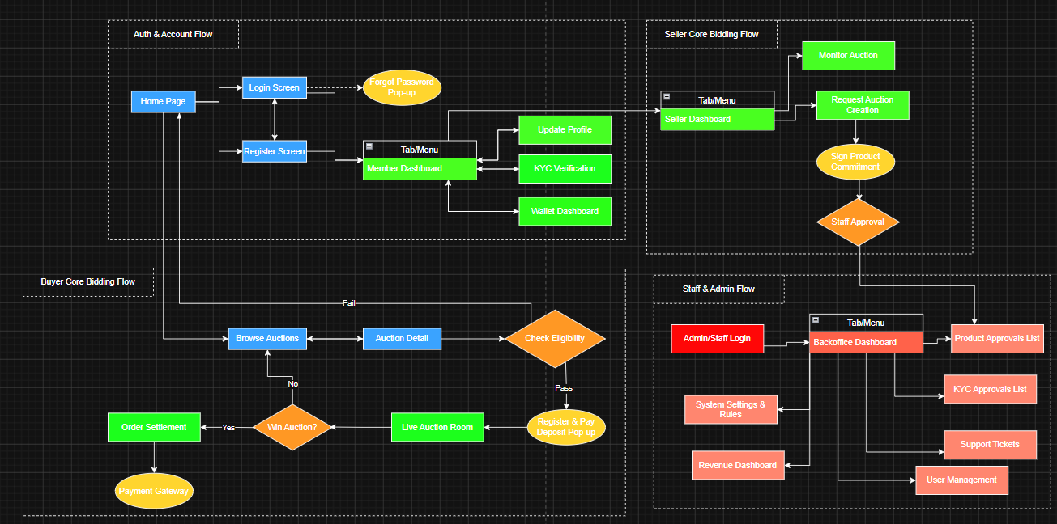
Picture 7. Screens flow

2.2 Screen Descriptions

# | Feature | Screen | Description
1 | Auth & Account | Home Page | Displays general information, highlighted auction sessions, and public menus for all users (Guests and Members).
2 | Auth & Account | Login Screen | Allows users to authenticate and access the system using their email and password or social accounts (Google/Facebook).
3 | Auth & Account | Register Screen | Allows Guests to create a new Member account by providing necessary registration details.
4 | Auth & Account | Member Dashboard | The main hub for authenticated members to navigate to their personal profile, KYC verification, and e-wallet features.
5 | Auth & Account | Update Profile | Allows Members to view and update their personal information, such as avatar, address, and contact details.
6 | Auth & Account | KYC Verification | Allows Members to upload identity documents (ID card/Passport) for system verification before participating in auctions.
7 | Payment & Wallet | Wallet Dashboard | Manages the user's e-wallet balance, transaction history, and allows them to perform deposit or withdrawal requests.
8 | Core Bidding | Browse Auctions | Displays a list of available, upcoming, or past auction sessions with search and filtering capabilities.
9 | Core Bidding | Auction Detail | Shows comprehensive product information, current starting/highest price, bidding history, and AI-generated evaluations.
10 | Core Bidding | Live Auction Room | The real-time bidding interface where qualified Buyers can observe the auction and place new bids.
11 | Core Bidding | Order Settlement | Allows winning Buyers to process the final remaining payment for the product they won.
12 | Core Bidding | Seller Dashboard | A dedicated workspace for Sellers to manage their product listings and monitor their ongoing auctions.
13 | Core Bidding | Request Auction Creation | A data entry form for Sellers to input product details, upload images, and request the creation of a new auction session.
14 | Admin & Staff | Backoffice Dashboard | The main overview for system administrators and Staff to view quick statistics, system alerts, and access management modules.
15 | Admin & Staff | Product Approvals List | Allows Staff to view, review, and approve or reject auction creation requests submitted by Sellers.
16 | Admin & Staff | User Management | Allows Admin to view user details, manage system roles, and suspend or ban user accounts based on policy violations.

2.3 Screen Authorization

Screen | Guest | Member | Buyer | Seller | Staff | Admin
Home Page | X | X | X | X | X | X
Login / Register Screen | X
<<Screen Name2>> |  | X | X | X
Member Dashboard |  | X | X | X
Update Profile & KYC |  | X | X | X
↳ Query Own Data |  | X | X | X
↳ Update Own Data |  | X | X | X
Wallet Dashboard |  | X | X | X
↳ Query Own Data |  | X | X | X
↳ Add New Data (Deposit) |  | X | X | X
↳ Update Own Data (Withdraw) |  | X | X | X
Browse Auctions & Detail | X | X | X | X | X | X
↳ Query All Data | X | X | X | X | X | X
Live Auction Room |  |  | X | X | X | X
↳ Query All Data (View Bids) |  |  | X | X | X | X
↳ Add New Data (Place Bid) |  |  | X
Seller Dashboard |  |  |  | X
Request Auction Creation |  |  |  | X
↳ Query Own Data |  |  |  | X
↳ Add New Data |  |  |  | X
Backoffice Dashboard |  |  |  |  | X | X
Product Approvals List |  |  |  |  | X | X
↳ Query All Data |  |  |  |  | X | X
↳ Update All Data (Approve/Reject) |  |  |  |  | X | X
Support Tickets |  |  |  |  | X | X
↳ Query All Data |  |  |  |  | X | X
↳ Update All Data (Reply/Close) |  |  |  |  | X | X
System Settings & Rules |  |  |  |  |  | X
↳ Query All Data |  |  |  |  |  | X
↳ Update All Data |  |  |  |  |  | X
User Management |  |  |  |  |  | X
↳ Query All Data |  |  |  |  |  | X
↳ Update All Data (Ban/Suspend) |  |  |  |  |  | X

2.4 Non-UI Functions

# | Feature | System Function | Description
1 | Core Bidding | Close Auction Automatically | A background scheduler (cron job) that runs periodically to check for active auctions where the current time exceeds the EndTime. It automatically updates the auction status to 'Closed', locks further bidding, and determines the highest bidder as the winner.
2 | Payment & Wallet | Refund Deposit | An automated background service that triggers immediately after an auction is closed. It queries the database to identify all Buyers who placed a deposit but did not win, and automatically returns the initial deposit amount back to their e-wallets.
3 | Core Bidding | Evaluate Product via AI | A backend API service that integrates with an AI model. It receives the product description and images submitted by the Seller, processes the data, and returns an automated price suggestion and authenticity evaluation score.
4 | Auth & Account | Account Lockout Security | A background security listener that tracks failed login attempts. If a user inputs wrong logging-in details 6 times continuously, the system automatically locks the account for 30 minutes without requiring Admin intervention.

3. System High Level Design

3.1 Database Design

a. Database Schema

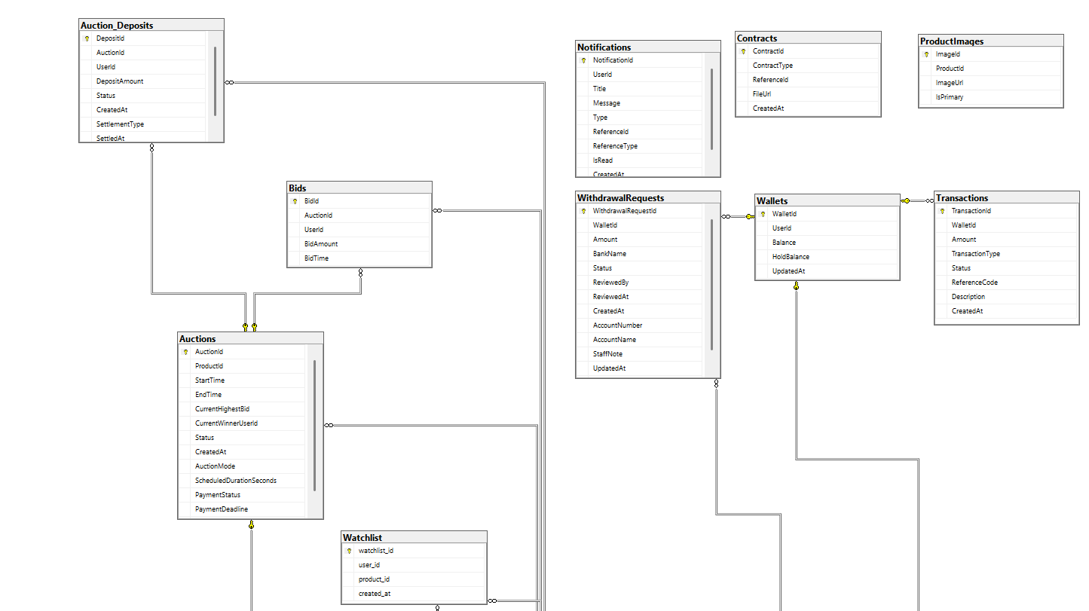
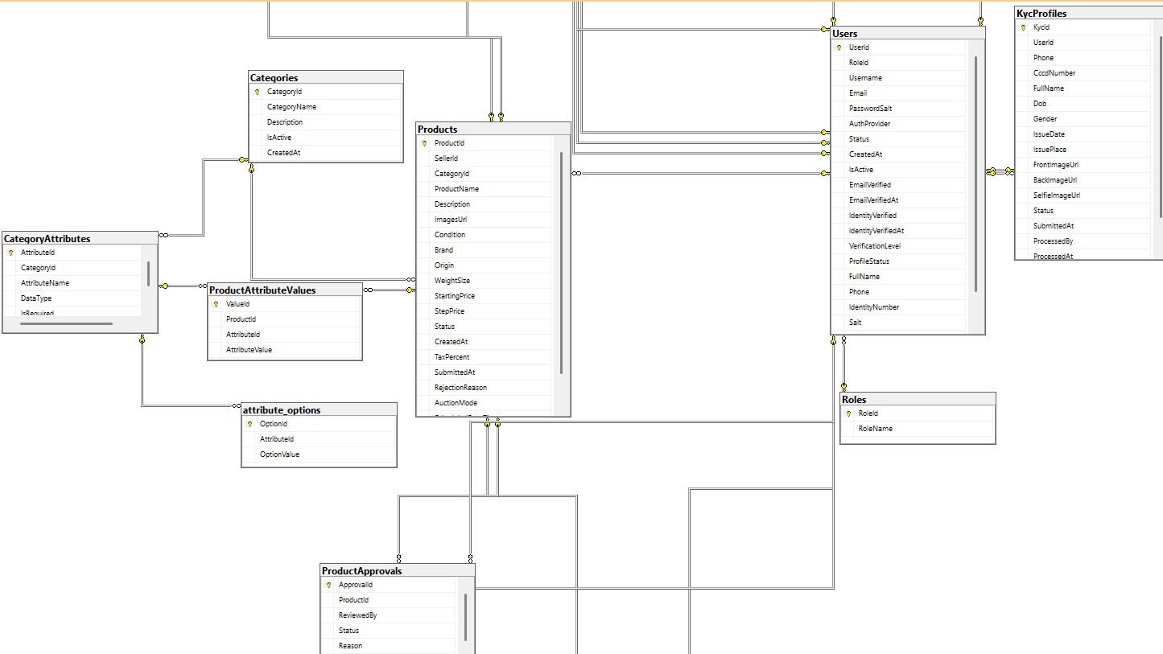


b. Table Descriptions

No | Table | Description
01 | Roles | Stores user roles within the system.  - Primary keys: RoleID  - Foreign keys: None
02 | Users | Stores user account information.  - Primary keys: UserID  - Foreign keys: RoleID
03 | KycProfiles | Stores user identity verification (KYC) profiles.  - Primary keys: KycId  - Foreign keys: UserID
04 | Categories | Manages product categories.  - Primary keys: CategoryId  - Foreign keys: None
05 | Products | Stores detailed information about products.  - Primary keys: ProductId  - Foreign keys: SellerId, CategoryId
06 | ProductApprovals | Stores information and the approval status of products.  - Primary keys: ApprovalId  - Foreign keys: ProductId, ReviewedBy
07 | Contracts | Stores contracts or related documents.  - Primary keys: ContractId  - Foreign keys: None
08 | Auctions | Stores information about auction sessions.  - Primary keys: AuctionId  - Foreign keys: ProductId
09 | Bids | Stores the bidding history of users in auction sessions.  - Primary keys: BidId  - Foreign keys: AuctionId, UserId
10 | Auction_Deposits | Stores information about user deposits for participating in auctions.  - Primary keys: DepositId  - Foreign keys: AuctionId, UserId
11 | Wallets | Manages user e-wallets and balances.  - Primary keys: WalletId  - Foreign keys: UserID
12 | Transactions | Stores the history of wallet transactions (deposits, withdrawals, payments).  - Primary keys: TransactionId  - Foreign keys: WalletId

3.2 Code Packages
[Provide the package diagram for each sub-system. The content of this section including the overall package diagram, the explanation, package and class naming conventions in each package. Please see the sample & description table format below]
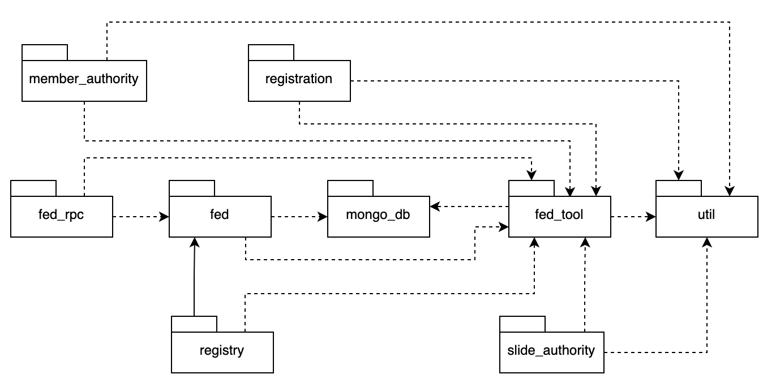
Package descriptions
No | Package | Description
01 | Member_authority | <Description of the package>
02 | registration | <Description of the package>
03 | …

II. Requirement Specifications

1. Register

1.1 UC-01_Register

a. Functionalities

UC ID and Name: | UC-01_Register
Created By: | Tuan | Date Created: | 29/Jun/2026
Primary Actor: | Guest | Secondary Actors:
Trigger: | Guest clicks Register from the Home Page or Login Screen.
Description: | A Guest creates a Member account by entering required registration information and confirming the account.
Preconditions: | PRE-1: Guest is not logged in.  PRE-2: Registration service is available.
Postconditions: | POST-1: A new Member account is created with default role Member.  POST-2: Verification message is sent if email verification is required.  POST-3: Registration action is logged.
Normal Flow: | 01.0 Register  1. Guest opens Register Screen.  2. System displays registration form.  3. Guest enters name, email, password, phone, and required information.  4. System validates required fields, email format, password policy, and duplicate email.  5. Guest submits the form.  6. System stores the new account, assigns Member role, and shows success message.  7. System redirects Guest to Login Screen or Member Dashboard after verification.
Alternative Flows: | 1.1 Social registration: Guest chooses Google/Facebook, provider verifies account, system creates Member profile, then continues from normal flow step 6.
Exceptions: | 1.0.E1 Email already exists: system informs Guest and asks for another email or Login.  1.0.E2 Invalid input: system highlights invalid fields and does not create account.  1.0.E3 Email service unavailable: account is created as pending verification and resend option is shown.
Priority: | High (Medium, Low), Must Have (Should Have, Could Have),..
Frequency of Use: | High, many times per day.
Business Rules: | BR-01, BR-02, BR-03, BR-17, BR-18
Other Information: | Registration must prevent duplicate accounts by email and phone where configured.
Assumptions: | Guest provides valid contact information.

b. Business Rules

ID | Business Rule | Business Rule Description
BR-01 | Role-Based Access Control | Every screen and function must check the authenticated user role before allowing access.
BR-02 | Account Verification | Only active, non-locked, non-banned accounts may use authenticated features.
BR-03 | Password Protection | Passwords must be stored using a one-way encoded hash and must never be displayed in plain text.
BR-17 | Audit Logging | Login, approval, payment, bidding, dispute, and configuration actions must be recorded in audit logs.
BR-18 | Notification Rule | Important account, auction, payment, approval, and dispute events must generate notifications to relevant users.

2. Common Functions

2.1 UC-2_Login System

a. Functional Description

UC ID and Name: | UC-2_Login System
Created By: | MinhNNT | Date Created: | 16/Jun/2023
Primary Actor: | Customer | Secondary Actors: | None
Trigger: | User clicks Login button from the page header, or  User accesses an authenticated feature (from a link or type the page URL directly into the address bar)
Description: | As a user, I want to be able to log into the system so that I can use the system’s authenticated features and access my personalized account.
Preconditions: | User account has been created & authorized
Postconditions: | - User logs in the system successfully  - The system tracked successful login into the Activity Log
Normal Flow | 2.0 Login System  1. User accesses the User Login screen  2. User types in the login details or choo other login options (see 2.1 and 2.2)  3. User clicks the Login button  4. System validates the login details (see 2.0.E1)  5. System allows user to access  6. System tracks user’s success login to the Activity Log  7. System accesses the Home Page (or the previous calling page if any)
Alternative Flows: | 2.1 Google Login  1. User chooses to login system using Google account  2. System redirects the user to the Google’s Login screen  3. User types in the Google account details and chooses to login  4. Google validates user’s login information successfully and redirect him/her back to the system  5. Return to step 5 of normal flow.  2.2 Facebook Login  1. User chooses to login system using Facebook account  2. System redirects the user to the Facebook’s Login screen  3. User types in the Facebook account details and chooses to login  4. Facebook validates user’s login information successfully and redirect him/her back to the system  5. Return to step 5 of normal flow.
Exceptions: | 2.0.E1 System can’t authenticate the user  1. The Error Message screen is shown to the user  2. User cancels the logging in => UC stops, change to UC-1_View Home Page  3. User clicks “Forgot Password?” link => change to UC-3_Reset Password  4. User clicks “Register” link => change to UC-4_Register User Account
Priority: | Must Have
Frequency of Use: | Very high, every active session.
Business Rules: | FR1, FR2, FR3
Other Information: | Session expiration and logout must clear authentication tokens.
Assumptions: | Authentication providers are available for social login.

b. Business Rules

ID | Business Rule | Business Rule Description
FR1 | Password Encoding | User’s password must be encoded with MD5 hashing
FR2 | Invalid Logging In | User can’t be authenticated to login the system if below cases  - His/her logging-in details are incorrect  - His/her account has not been verified  - His/her account has been locked or blocked
FR3 | Account Locking | If user inputs wrong logging-in details 6 times continuously, his/her account would be locked in 30 minutes

2.2 UC-03 - Login with Google

UC ID and Name: | UC-03 - Login with Google
Created By: | Auth & Account | Date Created: | 16/Jun/2026
Primary Actor: | Guest, Member | Secondary Actors: | None
Trigger: | User selects Login with Google.
Description: | User authenticates through Google as an alternative login path.
Preconditions: | Google identity provider is available.
Postconditions: | Mapped user account is authenticated or new account linking is requested.
Normal Flow | 1. User selects Google login option.  2. System redirects to Google consent/authentication page.  3. Google validates user identity and returns signed response.  4. System maps Google email to an existing account or starts account linking.  5. System applies account status and role checks.
Alternative Flows: | If email is not mapped, system may ask the user to register/link account.
Exceptions: | Provider failure, denied consent or banned account blocks login.
Priority: | Medium
Frequency of Use: | Very high, every active session.
Business Rules: | BR-01, BR-02, BR-19
Other Information: | Session expiration and logout must clear authentication tokens.
Assumptions: | Authentication providers are available for social login.

2.3 UC-04 - Reset Password

UC ID and Name: | UC-04 - Reset Password
Created By: | Auth & Account | Date Created: | 16/Jun/2026
Primary Actor: | Guest, Member | Secondary Actors: | None
Trigger: | User selects Forgot Password from Login.
Description: | User resets password when unable to log in.
Preconditions: | User owns a registered email account.
Postconditions: | Password is updated and reset token is invalidated.
Normal Flow | 1. User requests password reset.  2. System asks for registered email.  3. System sends single-use reset token.  4. User opens reset link and enters new password.  5. System validates token and password policy.  6. System stores new password hash and invalidates token.
Alternative Flows: | This use case extends UC-02 Login.
Exceptions: | Expired token, invalid token or weak password blocks reset.
Priority: | High
Frequency of Use: | BR-03, BR-06, BR-19, BR-20
Business Rules: | This use case extends UC-02 Login.
Other Information: | Session expiration and logout must clear authentication tokens.
Assumptions: | Authentication providers are available for social login.

3 . Member

3.1 UC-05 - Update Profile

UC ID and Name: | UC-05 - Update Profile
Created By: | Member | Date Created: | 16/Jun/2026
Primary Actor: | Member | Secondary Actors: | None
Trigger: | Member opens profile management.
Description: | Member updates personal profile information.
Preconditions: | Member is authenticated and active.
Postconditions: | Profile information is updated and audited.
Normal Flow | 1. Member opens profile screen.  2. System displays current profile data.  3. Member updates allowed fields.  4. System validates data format and ownership.  5. System saves changes and shows success message.
Alternative Flows: | Member may cancel and keep existing data.
Exceptions: | Invalid phone/email/address format blocks update.
Priority: | Medium
Frequency of Use: | BR-01, BR-02, BR-19
Business Rules: | Member opens profile management.
Other Information: | Session expiration and logout must clear authentication tokens.
Assumptions: | Authentication providers are available for social login.

3.2 UC-06 - Submit KYC Verification

UC ID and Name: | UC-06 - Submit KYC Verification
Created By: | Member | Date Created: | 16/Jun/2026
Primary Actor: | Member | Secondary Actors: | None
Trigger: | Member opens KYC verification.
Description: | Member submits identity documents for KYC approval.
Preconditions: | Member is authenticated and active.
Postconditions: | KYC profile becomes Pending Review and Staff is notified.
Normal Flow | 1. Member opens KYC screen.  2. System displays required information and current status.  3. Member enters legal information and uploads documents.  4. System validates required fields and file constraints.  5. System stores document references and creates pending KYC request.  6. System notifies Staff for review.
Alternative Flows: | Rejected KYC can be resubmitted with corrected information.
Exceptions: | Missing documents, invalid files or duplicate pending request is rejected.
Priority: | High
Frequency of Use: | BR-07, BR-19, BR-20
Business Rules: | Member opens KYC verification.
Other Information: | Member submits identity documents for KYC approval.
Assumptions: | Member is authenticated and active.

4 . Member Wallet

4.1 UC-07 - Access Wallet Dashboard

UC ID and Name: | UC-07 - Access Wallet Dashboard
Created By: | Member Wallet | Date Created: | 16/Jun/2026
Primary Actor: | Member | Secondary Actors: | None
Trigger: | Member opens Wallet Dashboard.
Description: | Member views wallet balance, held funds and transaction history.
Preconditions: | Member is authenticated and active.
Postconditions: | Wallet data is displayed.
Normal Flow | 1. Member opens wallet dashboard.  2. System loads wallet balance and held amount.  3. System displays recent transactions.  4. Member can choose deposit or withdrawal actions.
Alternative Flows: | If no wallet exists, system creates or initializes one according to policy.
Exceptions: | Inactive account cannot access wallet functions.
Priority: | High
Frequency of Use: | BR-01, BR-02, BR-19
Business Rules: | Member opens Wallet Dashboard.
Other Information: | Member submits identity documents for KYC approval.
Assumptions: | Member is authenticated and active.

4.2 UC-08 - Deposit Funds

UC ID and Name: | UC-08 - Deposit Funds
Created By: | Member Wallet | Date Created: | 16/Jun/2026
Primary Actor: | Member, Payment Gateway | Secondary Actors: | None
Trigger: | Member selects Deposit Funds.
Description: | Member tops up wallet through payment gateway.
Preconditions: | Member is authenticated and amount is valid.
Postconditions: | Successful payment creates wallet credit transaction.
Normal Flow | 1. Member enters deposit amount.  2. System validates amount and creates pending transaction.  3. System redirects member to payment gateway.  4. Payment Gateway processes payment and returns callback.  5. System validates callback signature and updates wallet ledger.  6. System notifies member of result.
Alternative Flows: | Member may cancel before gateway confirmation.
Exceptions: | Invalid signature, duplicate callback or failed payment does not update balance.
Priority: | High
Frequency of Use: | BR-14, BR-19, BR-20
Business Rules: | Member selects Deposit Funds.
Other Information: | Member submits identity documents for KYC approval.
Assumptions: | Member is authenticated and active.

4.3 UC-09 - Request Withdrawal

UC ID and Name: | UC-09 - Request Withdrawal
Created By: | Member Wallet | Date Created: | 16/Jun/2026
Primary Actor: | Member, Payment Gateway | Secondary Actors: | None
Trigger: | Member selects Request Withdrawal.
Description: | Member requests wallet withdrawal to bank account.
Preconditions: | Member is active, KYC-approved and has withdrawable balance.
Postconditions: | Withdrawal request is created with Pending Review status.
Normal Flow | 1. Member opens withdrawal form.  2. System displays available balance.  3. Member enters amount and bank information.  4. System validates amount, KYC and balance.  5. System creates withdrawal request for Staff review.
Alternative Flows: | Member may cancel request before Staff approval if policy allows.
Exceptions: | Insufficient balance, unapproved KYC or invalid bank data blocks request.
Priority: | High
Frequency of Use: | BR-07, BR-18, BR-19, BR-20
Business Rules: | Member selects Request Withdrawal.
Other Information: | Member submits identity documents for KYC approval.
Assumptions: | Member is authenticated and active.

5. Auction Discovery

5.1 UC-10 - Browse Auctions

UC ID and Name: | UC-10 - Browse Auctions
Created By: | Auction Discovery | Date Created: | 16/Jun/2026
Primary Actor: | Guest, Member, Buyer | Secondary Actors: | None
Trigger: | User opens auction list.
Description: | User views public auction listings.
Preconditions: | Auction catalogue is available.
Postconditions: | Auction list is displayed.
Normal Flow | 1. User opens Browse Auctions.  2. System loads ongoing, upcoming and completed auctions allowed for public view.  3. System displays auction summary cards.  4. User selects an auction to view details.
Alternative Flows: | Authenticated users may see personalized registration/deposit status.
Exceptions: | System shows empty state when no auction matches.
Priority: | High
Frequency of Use: | BR-01
Business Rules: | User opens auction list.
Other Information: | Member submits identity documents for KYC approval.
Assumptions: | Member is authenticated and active.

5.2 UC-11 - Search & Filter Auctions

UC ID and Name: | UC-11 - Search & Filter Auctions
Created By: | Auction Discovery | Date Created: | 16/Jun/2026
Primary Actor: | Guest, Member, Buyer | Secondary Actors: | None
Trigger: | User enters search/filter criteria.
Description: | User searches and filters auction listings.
Preconditions: | Auction list is available.
Postconditions: | Filtered auction results are displayed.
Normal Flow | 1. User enters keyword or selects filter options.  2. System validates filter values.  3. System queries matching auctions.  4. System displays result count and filtered list.
Alternative Flows: | User may clear all filters and return to full list.
Exceptions: | Invalid filter range is rejected.
Priority: | Medium
Frequency of Use: | BR-01
Business Rules: | User enters search/filter criteria.
Other Information: | User searches and filters auction listings.
Assumptions: | Auction list is available.

6 . Buyer

6.1 UC-12 - Register for Auction

UC ID and Name: | UC-12 - Register for Auction
Created By: | Buyer | Date Created: | 16/Jun/2026
Primary Actor: | Buyer | Secondary Actors: | None
Trigger: | Buyer selects Register for Auction.
Description: | Buyer registers for an upcoming auction.
Preconditions: | Buyer is authenticated, active, KYC-approved and auction is open for registration.
Postconditions: | Auction registration is recorded; deposit payment is required or completed.
Normal Flow | 1. Buyer opens auction detail.  2. System checks buyer eligibility.  3. System calculates required deposit.  4. Buyer confirms registration.  5. System creates registration and includes UC-13 Pay Deposit.
Alternative Flows: | If deposit already exists and is valid, registration becomes confirmed immediately.
Exceptions: | Closed registration, failed KYC or inactive account blocks registration.
Priority: | High
Frequency of Use: | BR-07, BR-08, BR-19, BR-20
Business Rules: | Buyer selects Register for Auction.
Other Information: | User searches and filters auction listings.
Assumptions: | Auction list is available.

6.2 UC-13 - Pay Deposit

UC ID and Name: | UC-13 - Pay Deposit
Created By: | Buyer | Date Created: | 16/Jun/2026
Primary Actor: | Buyer, Payment Gateway | Secondary Actors: | None
Trigger: | UC-12 includes Pay Deposit or Buyer selects Pay Deposit.
Description: | Buyer pays required deposit for a specific auction.
Preconditions: | Buyer has a pending auction registration and valid deposit amount.
Postconditions: | Deposit is confirmed and room access can be granted when auction starts.
Normal Flow | 1. System shows deposit amount.  2. Buyer confirms payment method.  3. System creates or updates deposit transaction.  4. Payment Gateway or wallet ledger confirms payment.  5. System marks deposit as Paid.
Alternative Flows: | Wallet balance may be held directly when sufficient.
Exceptions: | Failed payment or insufficient wallet balance keeps deposit unpaid.
Priority: | High
Frequency of Use: | BR-08, BR-14, BR-19, BR-20
Business Rules: | UC-12 includes Pay Deposit or Buyer selects Pay Deposit.
Other Information: | User searches and filters auction listings.
Assumptions: | Auction list is available.

6.3 UC-14 - Join Auction Room

UC ID and Name: | UC-14 - Join Auction Room
Created By: | Buyer | Date Created: | 16/Jun/2026
Primary Actor: | Buyer | Secondary Actors: | None
Trigger: | Buyer selects Join Auction Room.
Description: | Buyer enters a live auction room.
Preconditions: | Auction is live or ready; buyer has paid deposit.
Postconditions: | Buyer joins room and receives live auction state.
Normal Flow | 1. Buyer opens live auction room.  2. System includes UC-15 Verify Room Access.  3. System loads current price, time remaining and bid history.  4. System subscribes buyer to live updates.
Alternative Flows: | Buyer may enter as view-only if auction rules allow.
Exceptions: | No paid deposit, failed KYC or inactive auction blocks access.
Priority: | High
Frequency of Use: | BR-07, BR-08, BR-19
Business Rules: | Buyer selects Join Auction Room.
Other Information: | User searches and filters auction listings.
Assumptions: | Auction list is available.

6.4 UC-15 - Verify Room Access

UC ID and Name: | UC-15 - Verify Room Access
Created By: | Buyer | Date Created: | 16/Jun/2026
Primary Actor: | System | Secondary Actors: | None
Trigger: | UC-14 includes Verify Room Access.
Description: | System verifies whether Buyer can enter and bid in a room.
Preconditions: | Buyer requests live room access.
Postconditions: | Access is granted or denied with reason.
Normal Flow | 1. System checks account status.  2. System checks KYC status.  3. System checks auction status.  4. System checks deposit status.  5. System returns access decision.
Alternative Flows: | Staff/Admin/Seller monitoring access may be view-only.
Exceptions: | Any failed check denies bid-capable access.
Priority: | High
Frequency of Use: | BR-01, BR-07, BR-08
Business Rules: | UC-14 includes Verify Room Access.
Other Information: | User searches and filters auction listings.
Assumptions: | Auction list is available.

6.5 UC-16 - Place Bid

UC ID and Name: | UC-16 - Place Bid
Created By: | Buyer | Date Created: | 16/Jun/2026
Primary Actor: | Buyer | Secondary Actors: | None
Trigger: | Buyer submits bid amount.
Description: | Buyer submits a bid during live auction.
Preconditions: | Buyer has bid-capable room access and auction is live.
Postconditions: | Accepted bid becomes current highest bid and is broadcast.
Normal Flow | 1. Buyer enters bid amount.  2. System validates room access and auction status.  3. System validates amount against current highest bid and minimum increment.  4. System stores bid atomically.  5. System extends auction time when anti-sniping rule applies.  6. System broadcasts accepted bid.
Alternative Flows: | Buyer refreshes room state after stale bid rejection.
Exceptions: | Low, duplicate, stale or late bid is rejected.
Priority: | High
Frequency of Use: | BR-09, BR-10, BR-11, BR-19, BR-20
Business Rules: | Buyer submits bid amount.
Other Information: | User searches and filters auction listings.
Assumptions: | Auction list is available.

6.6 UC-17 - Settle Order Payment

UC ID and Name: | UC-17 - Settle Order Payment
Created By: | Buyer | Date Created: | 16/Jun/2026
Primary Actor: | Buyer, Payment Gateway | Secondary Actors: | None
Trigger: | Buyer opens settlement order after winning.
Description: | Winning buyer pays final remaining balance.
Preconditions: | Auction is closed, buyer is winner and settlement deadline has not passed.
Postconditions: | Order is paid and payment transaction is recorded.
Normal Flow | 1. Buyer opens settlement screen.  2. System displays remaining amount and deadline.  3. Buyer confirms payment.  4. System processes wallet/gateway transaction.  5. System updates order status and sends receipt.
Alternative Flows: | Buyer may top up wallet before settlement.
Exceptions: | Expired deadline, insufficient balance or gateway failure blocks settlement.
Priority: | High
Frequency of Use: | BR-15, BR-16, BR-19, BR-20
Business Rules: | Buyer opens settlement order after winning.
Other Information: | User searches and filters auction listings.
Assumptions: | Auction list is available.

7 . Seller

7.1 UC-18 - Request Auction Creation

UC ID and Name: | UC-18 - Request Auction Creation
Created By: | Seller | Date Created: | 16/Jun/2026
Primary Actor: | Seller | Secondary Actors: | None
Trigger: | Seller selects Request Auction Creation.
Description: | Seller submits product and auction request for review.
Preconditions: | Seller is authenticated, active and KYC-approved.
Postconditions: | Product/auction request is created with Pending Approval status.
Normal Flow | 1. Seller enters product details, images, starting price and schedule.  2. System includes UC-19 Sign Product Commitment.  3. System validates product data and category.  4. System may extend UC-20 Evaluate Product via AI.  5. System creates approval request for Staff.
Alternative Flows: | Seller may save request as draft.
Exceptions: | Invalid schedule, missing images or prohibited category blocks submission.
Priority: | High
Frequency of Use: | BR-07, BR-12, BR-13, BR-14, BR-19
Business Rules: | Seller selects Request Auction Creation.
Other Information: | Seller submits product and auction request for review.
Assumptions: | Seller is authenticated, active and KYC-approved.

7.2 UC-19 - Sign Product Commitment

UC ID and Name: | UC-19 - Sign Product Commitment
Created By: | Seller | Date Created: | 16/Jun/2026
Primary Actor: | Seller | Secondary Actors: | None
Trigger: | UC-18 includes Sign Product Commitment.
Description: | Seller signs commitment about product authenticity and condition.
Preconditions: | Seller is submitting an auction request.
Postconditions: | Commitment record is attached to product request.
Normal Flow | 1. System displays commitment terms.  2. Seller reviews terms.  3. Seller confirms acceptance/signature.  4. System stores signed commitment record.
Alternative Flows: | Seller may cancel and keep request as draft.
Exceptions: | Request cannot be submitted without commitment.
Priority: | High
Frequency of Use: | BR-13, BR-19
Business Rules: | UC-18 includes Sign Product Commitment.
Other Information: | Seller signs commitment about product authenticity and condition.
Assumptions: | Seller is submitting an auction request.

7.3 UC-20 - Evaluate Product via AI

UC ID and Name: | UC-20 - Evaluate Product via AI
Created By: | Seller | Date Created: | 16/Jun/2026
Primary Actor: | Seller, AI Evaluation Service | Secondary Actors: | None
Trigger: | System has enough product data/images or Seller requests AI evaluation.
Description: | AI suggests product price/risk information during auction request.
Preconditions: | Product draft contains description and images.
Postconditions: | AI evaluation is stored and shown to Seller/Staff.
Normal Flow | 1. System sends product data to AI service.  2. AI service returns suggested price, confidence and risk notes.  3. System stores evaluation result.  4. System displays advisory output in request/review screens.
Alternative Flows: | This use case extends UC-18 Request Auction Creation.
Exceptions: | AI failure does not block manual submission unless policy requires it.
Priority: | Medium
Frequency of Use: | BR-14, BR-19
Business Rules: | System has enough product data/images or Seller requests AI evaluation.
Other Information: | AI suggests product price/risk information during auction request.
Assumptions: | Product draft contains description and images.

7.4 UC-21 - Monitor Auction

UC ID and Name: | UC-21 - Monitor Auction
Created By: | Seller | Date Created: | 16/Jun/2026
Primary Actor: | Seller | Secondary Actors: | None
Trigger: | Seller opens active auction from Seller Dashboard.
Description: | Seller monitors owned auction progress.
Preconditions: | Seller owns product/auction.
Postconditions: | Seller sees current status, price and bidder summary where allowed.
Normal Flow | 1. Seller opens Seller Dashboard.  2. System loads seller auctions.  3. Seller selects active auction.  4. System displays live status and current highest bid.
Alternative Flows: | Seller may view historical auction status after close.
Exceptions: | Seller cannot place bids in own auction.
Priority: | Medium
Frequency of Use: | BR-01, BR-12, BR-19
Business Rules: | Seller opens active auction from Seller Dashboard.
Other Information: | Seller monitors owned auction progress.
Assumptions: | Seller owns product/auction.

7.5 UC-22 - View Settlement / Payout

UC ID and Name: | UC-22 - View Settlement / Payout
Created By: | Seller | Date Created: | 16/Jun/2026
Primary Actor: | Seller | Secondary Actors: | None
Trigger: | Seller opens settlement/payout detail.
Description: | Seller views settlement and payout status for completed auctions.
Preconditions: | Auction is closed and seller owns the auction.
Postconditions: | Settlement, commission and payout status are displayed.
Normal Flow | 1. Seller opens completed auction settlement.  2. System loads order payment and commission data.  3. System displays payout status and expected transfer information.
Alternative Flows: | Seller may open dispute if payout or order has an issue.
Exceptions: | Unauthorized seller cannot view another seller's payout.
Priority: | Medium
Frequency of Use: | BR-01, BR-16, BR-19
Business Rules: | Seller opens settlement/payout detail.
Other Information: | Seller views settlement and payout status for completed auctions.
Assumptions: | Auction is closed and seller owns the auction.

8 . Scheduler / Payment

8.1 UC-23 - Close Auction Automatically

UC ID and Name: | UC-23 - Close Auction Automatically
Created By: | Scheduler / Payment | Date Created: | 16/Jun/2026
Primary Actor: | Scheduler | Secondary Actors: | None
Trigger: | Auction EndTime is reached.
Description: | Scheduler closes auction when end time is reached.
Preconditions: | Auction is live.
Postconditions: | Auction is closed and winner/no-winner state is created.
Normal Flow | 1. Scheduler finds expired live auctions.  2. System locks auction record.  3. System re-checks actual EndTime.  4. System determines highest valid bid.  5. System closes auction and creates order/refund events.
Alternative Flows: | Anti-sniping may extend EndTime before closure.
Exceptions: | Concurrent close attempts must be idempotent.
Priority: | High
Frequency of Use: | BR-10, BR-11, BR-15, BR-17, BR-19
Business Rules: | Auction EndTime is reached.
Other Information: | Scheduler closes auction when end time is reached.
Assumptions: | Auction is live.

8.2 UC-24 - Refund Deposit

UC ID and Name: | UC-24 - Refund Deposit
Created By: | Scheduler / Payment | Date Created: | 16/Jun/2026
Primary Actor: | Scheduler, Payment Gateway | Secondary Actors: | None
Trigger: | Auction closes with one or more non-winning deposited buyers.
Description: | System refunds deposits to non-winning buyers.
Preconditions: | Auction is closed and deposit ledger is available.
Postconditions: | Refund transactions are created and buyers are notified.
Normal Flow | 1. System identifies non-winning deposited buyers.  2. System creates refund ledger entries.  3. Payment Gateway/wallet processes refund.  4. System marks deposit as refunded.  5. System notifies affected buyers.
Alternative Flows: | Failed refund is queued for retry/manual review.
Exceptions: | Duplicate refund request is ignored idempotently.
Priority: | High
Frequency of Use: | BR-17, BR-19, BR-20
Business Rules: | Auction closes with one or more non-winning deposited buyers.
Other Information: | System refunds deposits to non-winning buyers.
Assumptions: | Auction is closed and deposit ledger is available.

9 . Staff

9.1 UC-25 - Verify and Approve Products

UC ID and Name: | UC-25 - Verify and Approve Products
Created By: | Staff | Date Created: | 16/Jun/2026
Primary Actor: | Staff | Secondary Actors: | None
Trigger: | Staff opens product approval queue.
Description: | Staff reviews seller auction request and approves or rejects it.
Preconditions: | Product request is Pending Approval.
Postconditions: | Request becomes Approved/Scheduled or Rejected with reason.
Normal Flow | 1. Staff opens approval queue.  2. System displays product data, images, commitment and AI notes.  3. Staff reviews policy compliance.  4. Staff approves or rejects with reason.  5. System updates status and notifies Seller.
Alternative Flows: | Staff may request more information.
Exceptions: | Reject action requires reason.
Priority: | High
Frequency of Use: | BR-12, BR-13, BR-14, BR-19, BR-20
Business Rules: | Staff opens product approval queue.
Other Information: | Staff reviews seller auction request and approves or rejects it.
Assumptions: | Product request is Pending Approval.

9.2 UC-26 - Approve KYC Profiles

UC ID and Name: | UC-26 - Approve KYC Profiles
Created By: | Staff | Date Created: | 16/Jun/2026
Primary Actor: | Staff | Secondary Actors: | None
Trigger: | Staff opens KYC review queue.
Description: | Staff approves or rejects submitted KYC profiles.
Preconditions: | KYC profile is Pending Review.
Postconditions: | KYC profile becomes Approved or Rejected.
Normal Flow | 1. Staff opens KYC queue.  2. System displays submitted information and documents.  3. Staff verifies identity data.  4. Staff approves or rejects with reason.  5. System updates KYC status and notifies member.
Alternative Flows: | Staff may request resubmission.
Exceptions: | Invalid/missing reason blocks rejection.
Priority: | High
Frequency of Use: | BR-07, BR-19, BR-20
Business Rules: | Staff opens KYC review queue.
Other Information: | Staff approves or rejects submitted KYC profiles.
Assumptions: | KYC profile is Pending Review.

9.3 UC-27 - Approve Withdrawal Requests

UC ID and Name: | UC-27 - Approve Withdrawal Requests
Created By: | Staff | Date Created: | 16/Jun/2026
Primary Actor: | Staff | Secondary Actors: | None
Trigger: | Staff opens withdrawal review queue.
Description: | Staff reviews and approves/rejects withdrawal request.
Preconditions: | Withdrawal request is Pending Review.
Postconditions: | Withdrawal is Approved, Rejected or queued for payout.
Normal Flow | 1. Staff opens withdrawal request.  2. System displays member KYC, balance and bank data.  3. Staff checks fraud/risk information.  4. Staff approves or rejects request.  5. System updates status and notifies member.
Alternative Flows: | Approved request may be sent to payout provider.
Exceptions: | Insufficient balance or suspicious data blocks approval.
Priority: | High
Frequency of Use: | BR-18, BR-19, BR-20
Business Rules: | Staff opens withdrawal review queue.
Other Information: | Staff reviews and approves/rejects withdrawal request.
Assumptions: | Withdrawal request is Pending Review.

9.4 UC-28 - Handle Support Requests

UC ID and Name: | UC-28 - Handle Support Requests
Created By: | Staff | Date Created: | 16/Jun/2026
Primary Actor: | Staff | Secondary Actors: | None
Trigger: | Staff opens support queue.
Description: | Staff responds to user support tickets.
Preconditions: | Support request exists.
Postconditions: | Ticket is replied to, reassigned or closed.
Normal Flow | 1. Staff opens support ticket.  2. System displays conversation and related account/order data.  3. Staff writes response or applies resolution.  4. System stores response and notifies user.
Alternative Flows: | Staff escalates dispute-related ticket to Admin.
Exceptions: | Closed tickets cannot be edited except by policy.
Priority: | Medium
Frequency of Use: | BR-01, BR-19, BR-20
Business Rules: | Staff opens support queue.
Other Information: | Staff responds to user support tickets.
Assumptions: | Support request exists.

10 . Admin

10.1 UC-29 - Manage User Accounts

UC ID and Name: | UC-29 - Manage User Accounts
Created By: | Admin | Date Created: | 16/Jun/2026
Primary Actor: | Admin | Secondary Actors: | None
Trigger: | Admin opens User Management.
Description: | Admin manages user status, suspension, ban and unban actions.
Preconditions: | Admin is authenticated.
Postconditions: | User account status is updated and audited.
Normal Flow | 1. Admin searches/selects user.  2. System displays user profile, roles and status.  3. Admin chooses status action.  4. System validates admin permission.  5. System updates status and writes audit log.
Alternative Flows: | Admin may add note/reason for moderation action.
Exceptions: | Admin cannot demote or disable last active super admin if policy forbids it.
Priority: | High
Frequency of Use: | BR-01, BR-02, BR-19
Business Rules: | Admin opens User Management.
Other Information: | Admin manages user status, suspension, ban and unban actions.
Assumptions: | Admin is authenticated.

10.2 UC-30 - Set Roles & Permissions

UC ID and Name: | UC-30 - Set Roles & Permissions
Created By: | Admin | Date Created: | 16/Jun/2026
Primary Actor: | Admin | Secondary Actors: | None
Trigger: | Admin opens role management.
Description: | Admin assigns roles and permissions to users/staff.
Preconditions: | Admin has role-management privilege.
Postconditions: | Role/permission assignment is updated and audited.
Normal Flow | 1. Admin selects user or role.  2. System displays current permissions.  3. Admin updates role assignment.  4. System validates permission change.  5. System saves change and writes audit log.
Alternative Flows: | Admin may create a new staff role if supported.
Exceptions: | Invalid or unsafe role change is rejected.
Priority: | High
Frequency of Use: | BR-01, BR-19
Business Rules: | Admin opens role management.
Other Information: | Admin assigns roles and permissions to users/staff.
Assumptions: | Admin has role-management privilege.

10.3 UC-31 - Configure Bidding Rules

UC ID and Name: | UC-31 - Configure Bidding Rules
Created By: | Admin | Date Created: | 16/Jun/2026
Primary Actor: | Admin | Secondary Actors: | None
Trigger: | Admin opens bidding settings.
Description: | Admin configures auction bidding rules.
Preconditions: | Admin is authenticated.
Postconditions: | New versioned bidding rules are saved for future auctions.
Normal Flow | 1. Admin opens bidding settings.  2. System displays current anti-sniping, increment and duration values.  3. Admin edits values.  4. System validates allowed ranges.  5. System saves new settings version and writes audit log.
Alternative Flows: | Admin may preview impact before saving.
Exceptions: | Negative or out-of-range values are rejected.
Priority: | High
Frequency of Use: | BR-09, BR-11, BR-19
Business Rules: | Admin opens bidding settings.
Other Information: | Admin configures auction bidding rules.
Assumptions: | Admin is authenticated.

10.4 UC-32 - Configure Financial Policies

UC ID and Name: | UC-32 - Configure Financial Policies
Created By: | Admin | Date Created: | 16/Jun/2026
Primary Actor: | Admin | Secondary Actors: | None
Trigger: | Admin opens financial policy settings.
Description: | Admin configures commission, deposit and settlement policies.
Preconditions: | Admin is authenticated.
Postconditions: | New financial policy version is saved.
Normal Flow | 1. Admin opens financial policy screen.  2. System displays current commission, deposit range and settlement deadline.  3. Admin edits policy values.  4. System validates ranges and dependencies.  5. System saves policy version and audits change.
Alternative Flows: | Existing auctions keep their policy snapshot.
Exceptions: | Invalid rate/deadline configuration is rejected.
Priority: | High
Frequency of Use: | BR-08, BR-15, BR-16, BR-19
Business Rules: | Admin opens financial policy settings.
Other Information: | Admin configures commission, deposit and settlement policies.
Assumptions: | Admin is authenticated.

10.5 UC-33 - Edit Categories & Attributes

UC ID and Name: | UC-33 - Edit Categories & Attributes
Created By: | Admin | Date Created: | 16/Jun/2026
Primary Actor: | Admin | Secondary Actors: | None
Trigger: | Admin opens category management.
Description: | Admin maintains product categories and category attributes.
Preconditions: | Admin is authenticated.
Postconditions: | Category/attribute configuration is updated.
Normal Flow | 1. Admin opens category list.  2. Admin creates/updates/deactivates category or attribute.  3. System validates uniqueness and usage constraints.  4. System saves changes and audits action.
Alternative Flows: | Used categories may be deactivated instead of deleted.
Exceptions: | Deleting category with existing products is blocked.
Priority: | Medium
Frequency of Use: | BR-01, BR-19
Business Rules: | Admin opens category management.
Other Information: | Admin maintains product categories and category attributes.
Assumptions: | Admin is authenticated.

10.6 UC-34 - Manage Notifications

UC ID and Name: | UC-34 - Manage Notifications
Created By: | Admin | Date Created: | 16/Jun/2026
Primary Actor: | Admin | Secondary Actors: | None
Trigger: | Admin opens notification management.
Description: | Admin configures or broadcasts system notifications.
Preconditions: | Admin is authenticated.
Postconditions: | Notification configuration or broadcast is saved/sent.
Normal Flow | 1. Admin opens notification management.  2. Admin selects target audience and message.  3. System validates message and recipients.  4. System queues/sends notification.  5. System records notification event.
Alternative Flows: | Admin may schedule notification for later.
Exceptions: | Invalid audience or empty message is rejected.
Priority: | Medium
Frequency of Use: | BR-20, BR-19
Business Rules: | Admin opens notification management.
Other Information: | Admin configures or broadcasts system notifications.
Assumptions: | Admin is authenticated.

10. 7 UC-35 - View Auction History (System-wide)

UC ID and Name: | UC-35 - View Auction History (System-wide)
Created By: | Admin | Date Created: | 16/Jun/2026
Primary Actor: | Admin | Secondary Actors: | None
Trigger: | Admin opens system-wide auction history.
Description: | Admin reviews all auction history for monitoring and audit.
Preconditions: | Admin is authenticated.
Postconditions: | Auction history is displayed.
Normal Flow | 1. Admin opens history screen.  2. System loads auctions by status/date/filter.  3. Admin reviews auction details, bids and settlement state.
Alternative Flows: | Admin may filter by seller, buyer, category or status.
Exceptions: | Unauthorized access is blocked.
Priority: | Medium
Frequency of Use: | BR-01, BR-19
Business Rules: | Admin opens system-wide auction history.
Other Information: | Admin reviews all auction history for monitoring and audit.
Assumptions: | Admin is authenticated.

10.8 UC-36 - View Revenue Statistics

UC ID and Name: | UC-36 - View Revenue Statistics
Created By: | Admin | Date Created: | 16/Jun/2026
Primary Actor: | Admin | Secondary Actors: | None
Trigger: | Admin opens revenue dashboard.
Description: | Admin views revenue, commission and transaction statistics.
Preconditions: | Admin is authenticated.
Postconditions: | Revenue statistics are displayed.
Normal Flow | 1. Admin opens revenue statistics.  2. System loads settlement and commission data.  3. System displays charts/tables by date, category and auction.
Alternative Flows: | UC-37 Export Data Reports may extend this use case.
Exceptions: | Invalid date range is rejected.
Priority: | Medium
Frequency of Use: | BR-16, BR-19
Business Rules: | Admin opens revenue dashboard.
Other Information: | Admin views revenue, commission and transaction statistics.
Assumptions: | Admin is authenticated.

10.9 UC-37 - Export Data Reports

UC ID and Name: | UC-37 - Export Data Reports
Created By: | Admin | Date Created: | 16/Jun/2026
Primary Actor: | Admin | Secondary Actors: | None
Trigger: | Admin selects Export from reporting/statistics screen.
Description: | Admin exports filtered data reports.
Preconditions: | Report data is available.
Postconditions: | CSV/PDF/XLSX report is generated or queued.
Normal Flow | 1. Admin chooses report type and filters.  2. System validates filters.  3. System generates report file.  4. System returns download link or queued export status.
Alternative Flows: | This use case extends UC-36 View Revenue Statistics.
Exceptions: | Too-large export may be queued asynchronously.
Priority: | Low
Frequency of Use: | BR-01, BR-19
Business Rules: | Admin selects Export from reporting/statistics screen.
Other Information: | Admin exports filtered data reports.
Assumptions: | Report data is available.

10.10 UC-38 - View System Audit Logs

UC ID and Name: | UC-38 - View System Audit Logs
Created By: | Admin | Date Created: | 16/Jun/2026
Primary Actor: | Admin | Secondary Actors: | None
Trigger: | Admin opens audit log screen.
Description: | Admin reviews immutable system audit events.
Preconditions: | Admin is authenticated.
Postconditions: | Filtered audit events are displayed.
Normal Flow | 1. Admin opens audit logs.  2. System displays filters for actor, event type and date.  3. Admin applies filters.  4. System displays matching audit events.
Alternative Flows: | Admin may export audit results if policy allows.
Exceptions: | Audit records cannot be edited from this screen.
Priority: | High
Frequency of Use: | BR-19
Business Rules: | Admin opens audit log screen.
Other Information: | Admin reviews immutable system audit events.
Assumptions: | Admin is authenticated.

10.11 UC-39 - Resolve Disputes

UC ID and Name: | UC-39 - Resolve Disputes
Created By: | Admin | Date Created: | 16/Jun/2026
Primary Actor: | Admin | Secondary Actors: | None
Trigger: | Admin opens dispute case.
Description: | Admin resolves escalated buyer/seller disputes.
Preconditions: | Dispute exists and is assigned/open.
Postconditions: | Dispute decision is recorded and affected users are notified.
Normal Flow | 1. Admin opens dispute queue.  2. System displays order, payment, product and conversation evidence.  3. Admin reviews case and chooses resolution.  4. System records decision, updates dispute/order status and notifies users.
Alternative Flows: | Admin may request additional evidence before final decision.
Exceptions: | Closed dispute cannot be changed without privileged reopening.
Priority: | High
Frequency of Use: | BR-01, BR-19, BR-20
Business Rules: | Admin opens dispute case.
Other Information: | Admin resolves escalated buyer/seller disputes.
Assumptions: | Dispute exists and is assigned/open.

III. Design Specifications

1. <<Feature Name>>

1.1 <<SubFeature Name>>

a. <<Screen/Function Name>>
[Provide brief description of the screen/function + related UC here and other details as in the sub-sections]
- This screen allows a Guest to create a new Member account for using authenticated functions.

UI Design
[This is to describe the UI layout (Mockup prototype) & descriptions for screen fields/components]
- Register form contains required account fields: full name, email, password, confirm password, and action buttons.
<<Mockup prototype>>
Field Name | Field Type | Description
Field Group Name
Email* | Text Box | User inputs registered email address.
Password* | Password Box | User inputs password.
Login | Button | Authenticates user and creates session.
Register | Link/Button | Redirects Guest to Register Screen.
Forgot Password | Link | Redirects user to Reset Password flow.
Login with Google/Facebook | Button | Starts social login flow.

Database Access
[Provide the design description for the screen/function to access the database here: what table the screen/function would access, which transactions does it make (C-Create, R-Read, U-Update, or D-Delete), and how/purpose of the access (by providing Description and SQL commands)]
- Register screen creates a new Users record, reads the default Member role, and may create a notification for account verification.
Table | CRUD | Description
Users | R/U | Read user credentials/status; update failed-login count and lockout time.
Roles | R | Load role name and permissions.
AuditLogs | C | Record successful/failed login events.

SQL Commands
[Provide the detailed SQL (select, insert, update...) which are used in implementing the screen/function]
1/ Create new member account
INSERT INTO Users (FullName, Email, PasswordHash, RoleId, Status, CreatedAt)
VALUES (?, ?, ?, ?, ?, CURRENT_TIMESTAMP);

1.2 System Access

a. User Login
This screen allows user to be authenticated to the system screens/functionalities.
Related use cases:
- UC02_Login System

UI Design
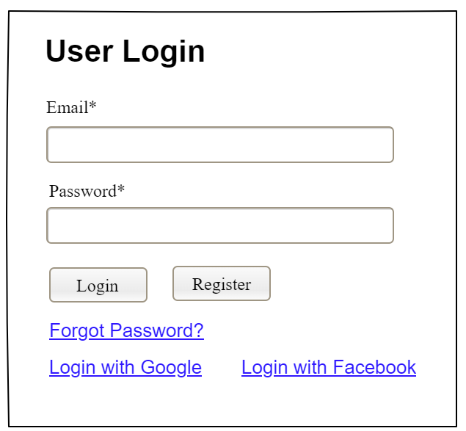

Field Name | Field Type | Description
Email* | Text Box | This is for user to input valid email address for logging in
Password* | Password Box | This is for user to input password for logging in
Login | Button | User clicks to authenticate him/herself into the system with provided email & password
Register | Button | User clicks to redirect to the User Register page for registering new user account to access the system
Forgot Password? | Hyperlink | User clicks to redirect to the Password Reset page for resetting his/her forgot password
Login with Google | Hyperlink | Allow user to login with his/her Google account
Login with Facebook | Hyperlink | Allow user to login with his/her Facebook account

Database Access
Table | CRUD | Description
User | R | Verify UserName & Password information
Setting, User | R | Specify the authorizations of the logged-in user

SQL Commands:
1/ Verify UserName & Password information
SELECT user_id, full_name, email, image_url, status
FROM user WHERE user_name = ? AND password = ?

2/ Specify the authorizations of the logged-in user
SELECT mapped_values FROM setting WHERE setting_id = ?
SELECT setting_name, mapped_values FROM setting WHERE setting_id IN (?)

b. Setting List

UI Design
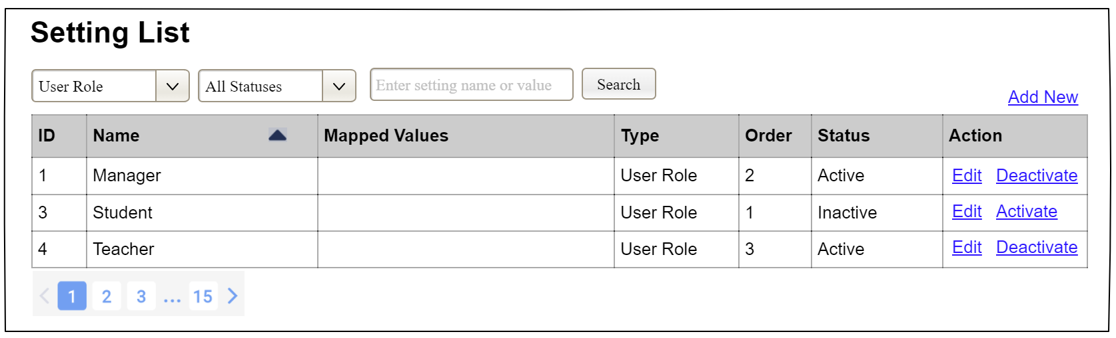

Field Name | Field Type | Description
Search Fields
Setting Type | Combo Box  Single-Choice | Filled with the list of current active setting types  Allow to filter the list by setting type;  Default value is “All Types”
Setting Status | Combo Box  Single-Choice | Values: All Statuses (default), Active, and Inactive  Allow to filter the list by status  Default value: “All Statuses”
Search Phase | Text Box  String (30) | Allow to search using the name or map values  Default value: blank
Search | Button | Click to refresh the list with the defined filter(s) and search phrase.
Add New | Hyperlink | Click to open the Setting Details page for adding new setting (master data)
Data Table
ID | Integer | Auto-increased identifier of the setting
Name | Text | Name of the setting
Mapped Values | Text | Supplementary information for the setting
Type | Text | Type of the setting
Order | Integer | Display order of the setting: the order of the setting type, displayed among the list of settings with the same type
Data Actions
Edit | icon | Click to open the Setting Details page for updating the relevant setting (master data)
Activate | icon | Shown when the data status is inactive. This is to activate the relevant setting (master data)
Deactivate | Ion | Shown when the data status is active. This is to deactivate the relevant setting (master data)

Database Access
Table | CRUD | Description
Setting | RU | Query the list of current settings from the database  Update status of a specific setting

SQL Commands:
1/ Query the list of current settings from the database
SELECT setting_id, setting_name, mapped_values, type_id, display_order, status
FROM setting WHERE (setting_type = ?) AND (status = ?) AND (setting_name LIKE ?)

2/ Update status of a specific setting
UPDATE setting SET status = ? WHERE setting_id = ?

c. Setting Details

UI Design
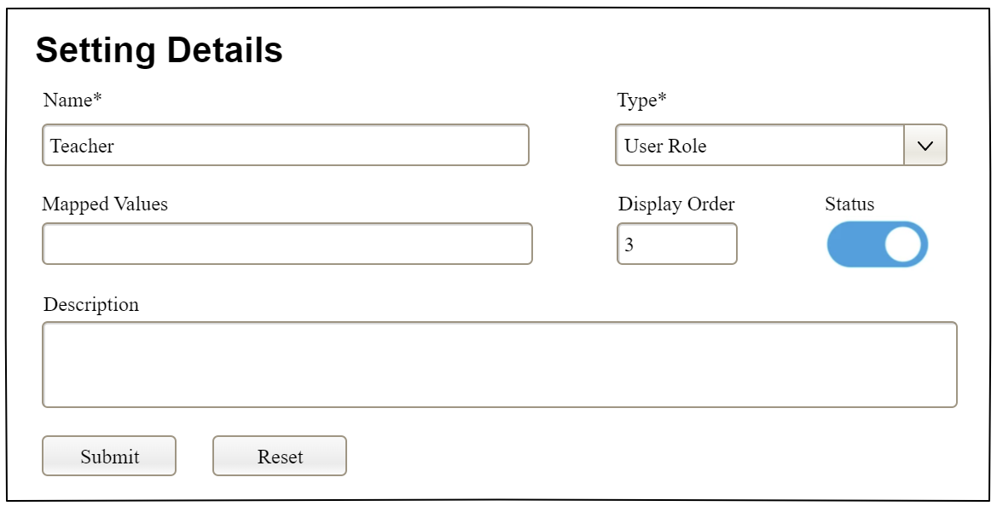

Field Name | Field Type | Description
Name* | Text Box  String (20) | Name of the setting
Type* | Combo Box  (Single Choice) | Type of the setting, filled with the list of setting types  Default value: the first type in the list
Mapped Values | Text Box  String (50) | Supplementary information for the setting (if any)
Order | Text Box  Integer (>=0) | Display order of the setting: the order of the setting type, displayed among the list of settings with the same type
Status | On/Off button | Status of the setting: Active or Inactive  Default value: Active
Description | Text Area  String (200) | Description of the setting
Submit | Button | Click to store new or updated setting details
Reset | Button | Click to reset the changes use has made on the screen fields back to the initial values when the screen is loaded

Database Access
…

Tables accessed: Auctions (R), Products (R), Bids (R), Auction_Deposits (C/R) to display auction detail, current bid, and registration/deposit status.

IV. Appendix

1. Assumptions & Dependencies
[Record any assumptions that were made when conceiving the project and writing this vision and scope document. Note any major dependencies the project must rely upon for success, such as specific technologies, third-party vendors, development partners, or other business relationships.]
<<Sample:
AS-1: Systems with appropriate user interfaces will be available for cafeteria employees to process the expected volume of meals ordered.
AS-2: Cafeteria staff and vehicles will be available to deliver all meals for specified delivery time slots within 15 minutes of the requested delivery time.
DE-1: If a restaurant has its own on-line ordering system, the Cafeteria Ordering System must be able to communicate with it bi-directionally.
>>
AS-1: Users have internet access and a valid email/phone number for account verification.
AS-2: Payment Gateway is available to process deposits, settlements, withdrawals, and refunds.
DE-1: The system depends on external services such as Payment Gateway, email/SMS notification service, and AI evaluation service.

ID | Type | Description
AS-1 | Assumption | Users have reliable internet access and a valid, accessible email address for account verification and notifications.
AS-2 | Assumption | Payment Gateway (VNPay, Stripe, or equivalent) is available and provides reliable transaction callbacks for deposit and withdrawal processing.
AS-3 | Assumption | AI Evaluation Service is available when Sellers submit auction requests. If unavailable, the system proceeds without the AI suggestion.
AS-4 | Assumption | All product images uploaded by Sellers are authentic and represent the actual items being auctioned.
AS-5 | Assumption | Staff members perform their review duties within 2 business days for KYC and product approvals.
DE-1 | Dependency | The system depends on an external Payment Gateway (VNPay/Stripe) for all financial transactions. System availability for deposits and withdrawals is contingent on the Payment Gateway's uptime.
DE-2 | Dependency | The system depends on an external Email/SMS notification service for sending transactional notifications (registration, KYC, auction events, payment confirmations).
DE-3 | Dependency | The Evaluate Product via AI feature depends on a third-party AI API. Unavailability of this API will not block auction creation but will disable the price suggestion feature.
DE-4 | Dependency | Real-time bidding in the Live Auction Room depends on a WebSocket server. Degraded WebSocket connectivity may cause bid display delays for some participants.

2. Limitations & Exclusions
[Identify any product features or characteristics that a stakeholder might anticipate, but which are not planned to be included in the new product]

- This version focuses on online auction management, bidding, wallet/payment, KYC approval, product approval, and administration. It does not include physical delivery tracking, in-app chat/video livestream, or direct real-time bank reconciliation outside the Payment Gateway.

# | Limitation / Exclusion | Detail
1 | No Physical Delivery Tracking | This version does not include logistics or physical delivery tracking. Product handoff arrangements between Buyer and Seller are out of scope.
2 | No In-App Chat or Video Livestream | Real-time text chat within auction rooms and video livestreaming of products are not included in this version.
3 | No Direct Bank Reconciliation | The system does not perform direct bank account reconciliation. All fund movements are managed through the Payment Gateway interface only.
4 | No Mobile Native Application | This version targets web browsers only. Native iOS/Android applications are not in scope.
5 | Single Currency | This version supports a single operating currency (VND). Multi-currency support is excluded.
6 | Maximum Concurrent Auctions | System performance is designed for up to 100 simultaneous active auction sessions. Higher concurrency may require infrastructure scaling.

3. Business Rules
[Provide common business rules that you must follow. The information can be provided in the table format as the sample below]
<<Sample
ID | Category | Rule Definition
BR-01 | Access Control | Every screen and function must verify the authenticated user's role before allowing access. Unauthorized access attempts must be blocked and logged.
BR-02 | Account Status | Only accounts with status 'Active' (not Pending, Locked, or Banned) may access authenticated features.
BR-03 | Password Hashing | Passwords must be stored using a one-way cryptographic hash (bcrypt, SHA-256 or stronger). Passwords must never be stored or transmitted in plain text.
BR-04 | Unique Account | Email address must be unique across all user accounts. The system must reject registration with a duplicate email.
BR-05 | Active Status Required | Users with status 'Locked', 'Banned', or 'Pending Verification' are not permitted to authenticate into the system.
BR-06 | Account Lockout | If a user enters incorrect credentials 6 times consecutively within a session, the account is automatically locked for 30 minutes. The lockout event must be recorded in AuditLogs.
BR-07 | Reset Token Expiry | Password reset tokens expire 15 minutes after generation and are single-use only.
BR-08 | KYC Requirement | Members must have an approved KYC profile before being permitted to place bids (as Buyer) or submit auction creation requests (as Seller).
BR-09 | Minimum Bid Increment | Each new bid must exceed the current highest bid by at least the platform minimum increment (configurable in SystemSettings; default: 50,000 VND).
BR-10 | Anti-Sniping | If a valid bid is placed within the anti-sniping window before auction end (default: 2 minutes), the EndTime is extended by the configured extension duration (default: 2 minutes). Both values are configurable.
BR-11 | Deposit Requirement | A Buyer must have a confirmed deposit payment for the specific auction before entering the Live Auction Room. The required deposit amount is (Starting Price x Deposit Rate %), configurable per auction by the Seller (within Admin-defined bounds).
BR-12 | Product Commitment | Sellers must digitally sign the Product Commitment Agreement before submitting an auction creation request. This agreement confirms product authenticity and condition.
BR-13 | Approval Required | All auction creation requests must pass Staff review and approval before being published as 'Scheduled'. Rejected requests must include a reason.
BR-14 | Minimum Deposit Amount | The minimum wallet top-up deposit is 10,000 VND. Amounts below this threshold are rejected.
BR-15 | Settlement Deadline | Winning Buyers must complete order settlement within 48 hours of auction close. Failure to settle may result in deposit forfeiture and an account warning/suspension.
BR-16 | Commission Calculation | Platform commission = Final Auction Price x Commission Rate (configurable in SystemSettings). Commission is deducted at settlement and recorded as a separate transaction.
BR-17 | Audit Logging | The following events must be recorded in AuditLogs: login/logout, registration, KYC submission/approval, auction creation/approval, bid placement, payment transactions, dispute actions, and all Admin configuration changes.
BR-18 | Notification Rule | The following events must trigger user notifications (in-app and/or email): registration confirmation, KYC approval/rejection, auction creation approval/rejection, auction win, settlement due reminder, payment confirmation, refund confirmation, and dispute resolution.
BR-19 | Refund on Loss | Buyers who participated in an auction but did not win must have their deposit automatically refunded to their e-wallet within 24 hours of the auction closing.
BR-20 | Withdrawal Approval | Withdrawal requests must be reviewed and approved by a Staff member before funds are disbursed to the user's bank account, to prevent fraudulent activity.
>>

4. ..

